**Ex 24-1 #1:**

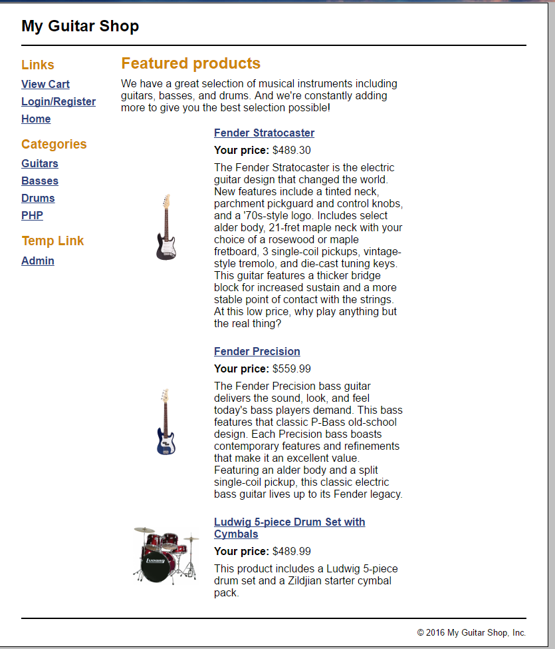

Able to run the application successfully.

**Ex 24-1 #2:**

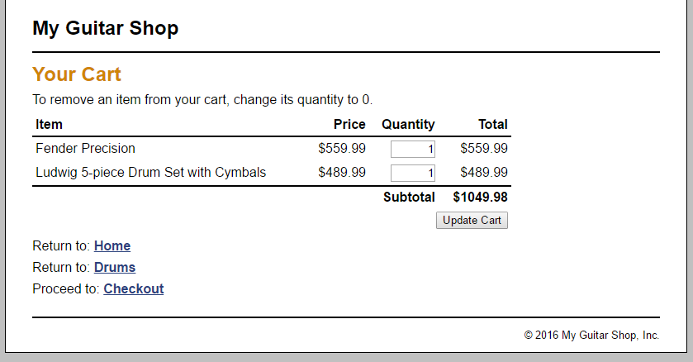

Able to add items to the car as well as remove them.

**Ex 24-1 #3 and 4:**

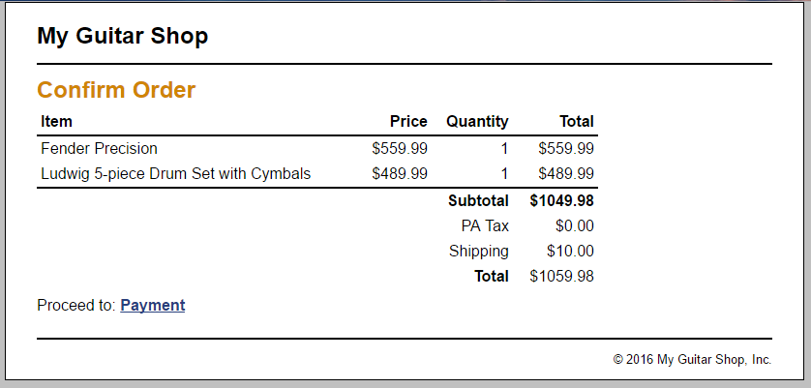

Able to successfully register for account and sign in as well as use checkout.

**Ex 24-1 #5:**

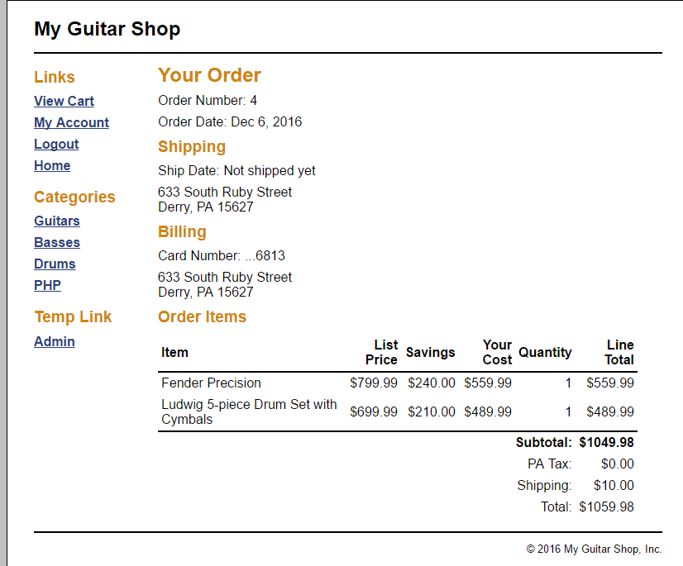

Able to successfully pay for items.

**Ex 24-1 #6:**

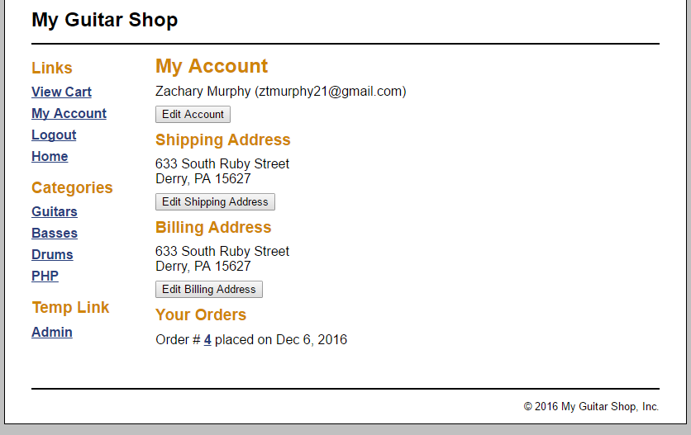

I am also able to view my account information successfully.

**Ex 24-1 #7:**

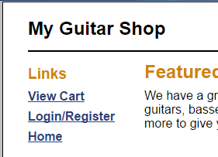

Able to successfully log out of account.

**Ex 24-1 #’s 8-11:**

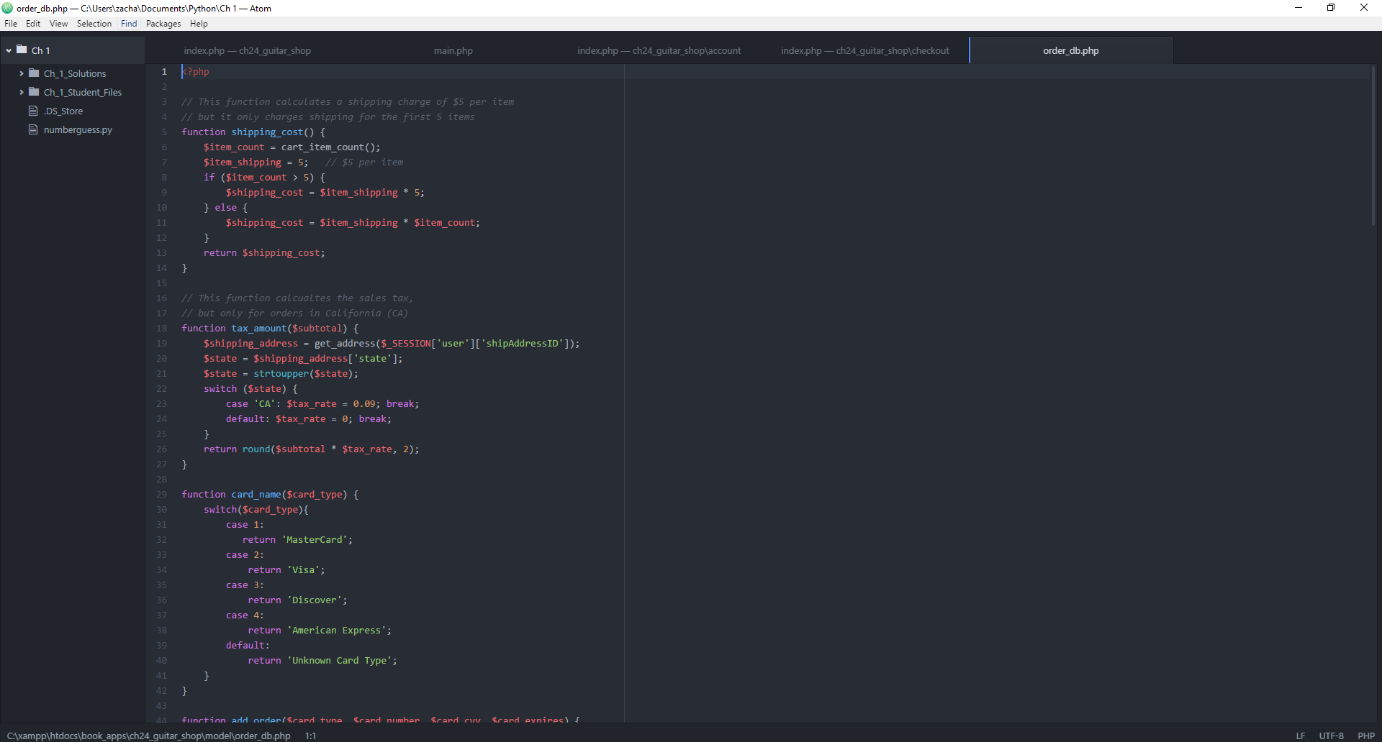

Able to review the code for all items.

**Ex 24-1 #12:**

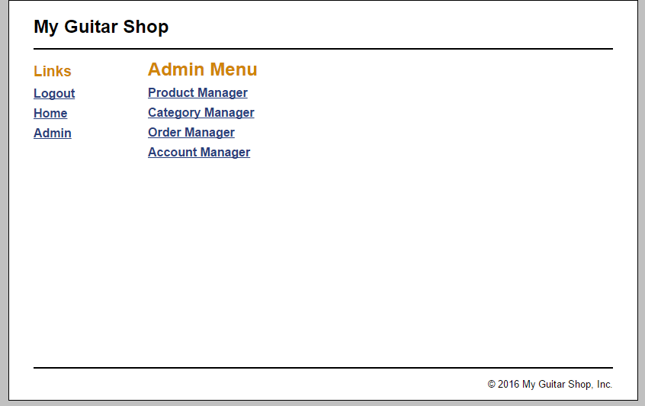

Able to login as admin.

**Ex 24-1 # 13:**

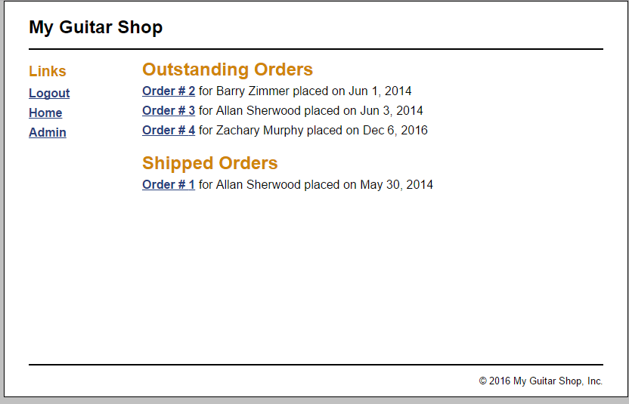

Able to view all orders.

**Ex 24-1 # 14:**

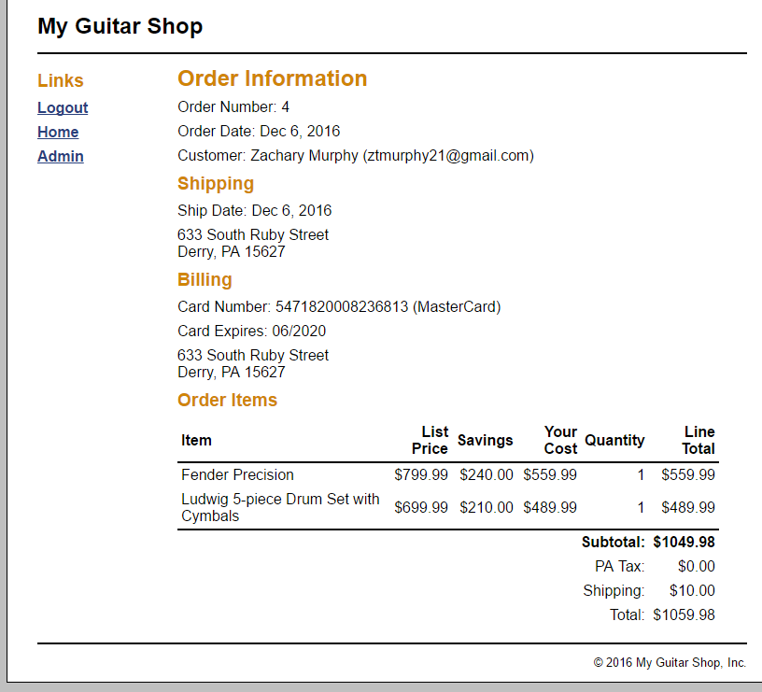

Able to successfully ship orders.

**Ex 24-1 #15:**



Able to return to the admin menu.

**Ex 24-1 # 16:**

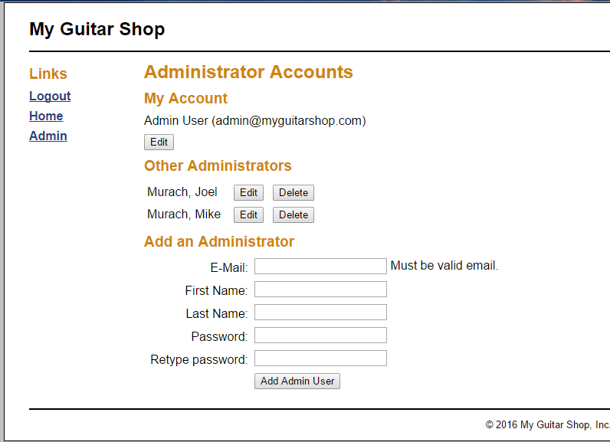

Able to view the account manager.

**Ex 24-1 #17:**

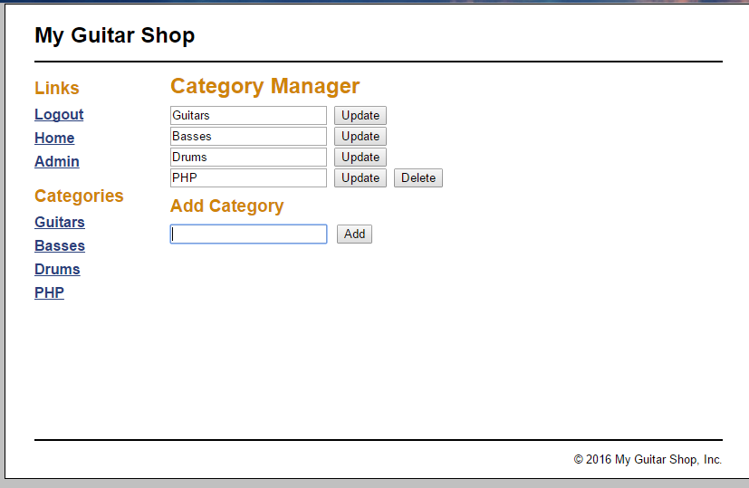

Able to add and remove categories.

**Ex 24-1 #18:**

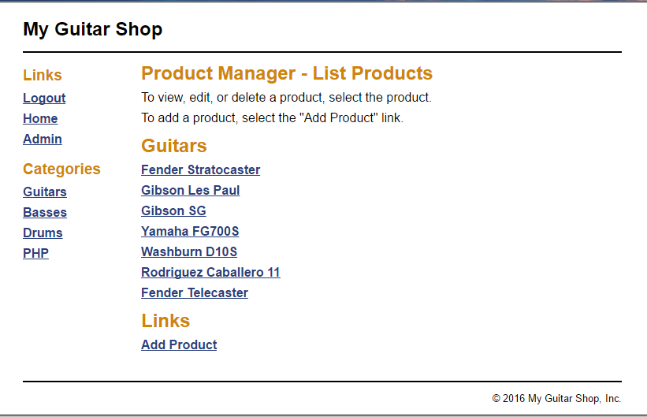

Able to use the product manager portion.

**Ex 24-1 #19:**

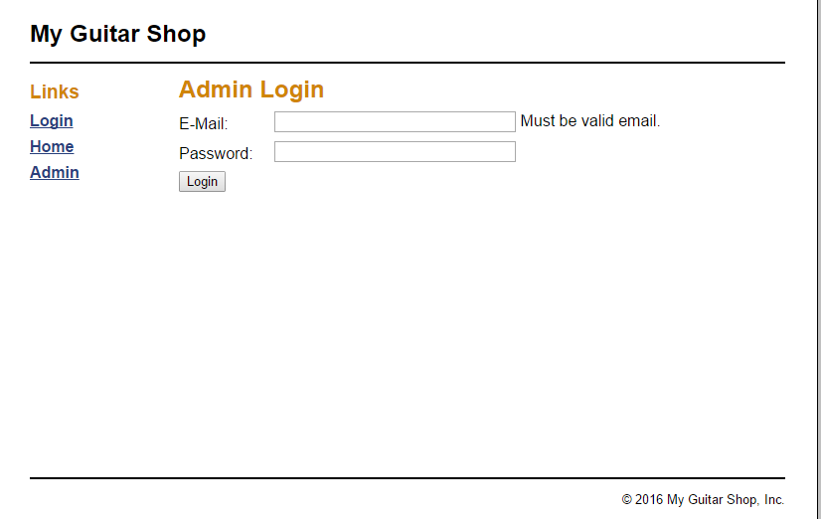

Able to successfully logout.

**Ex 24-1 #’s 20-24:**

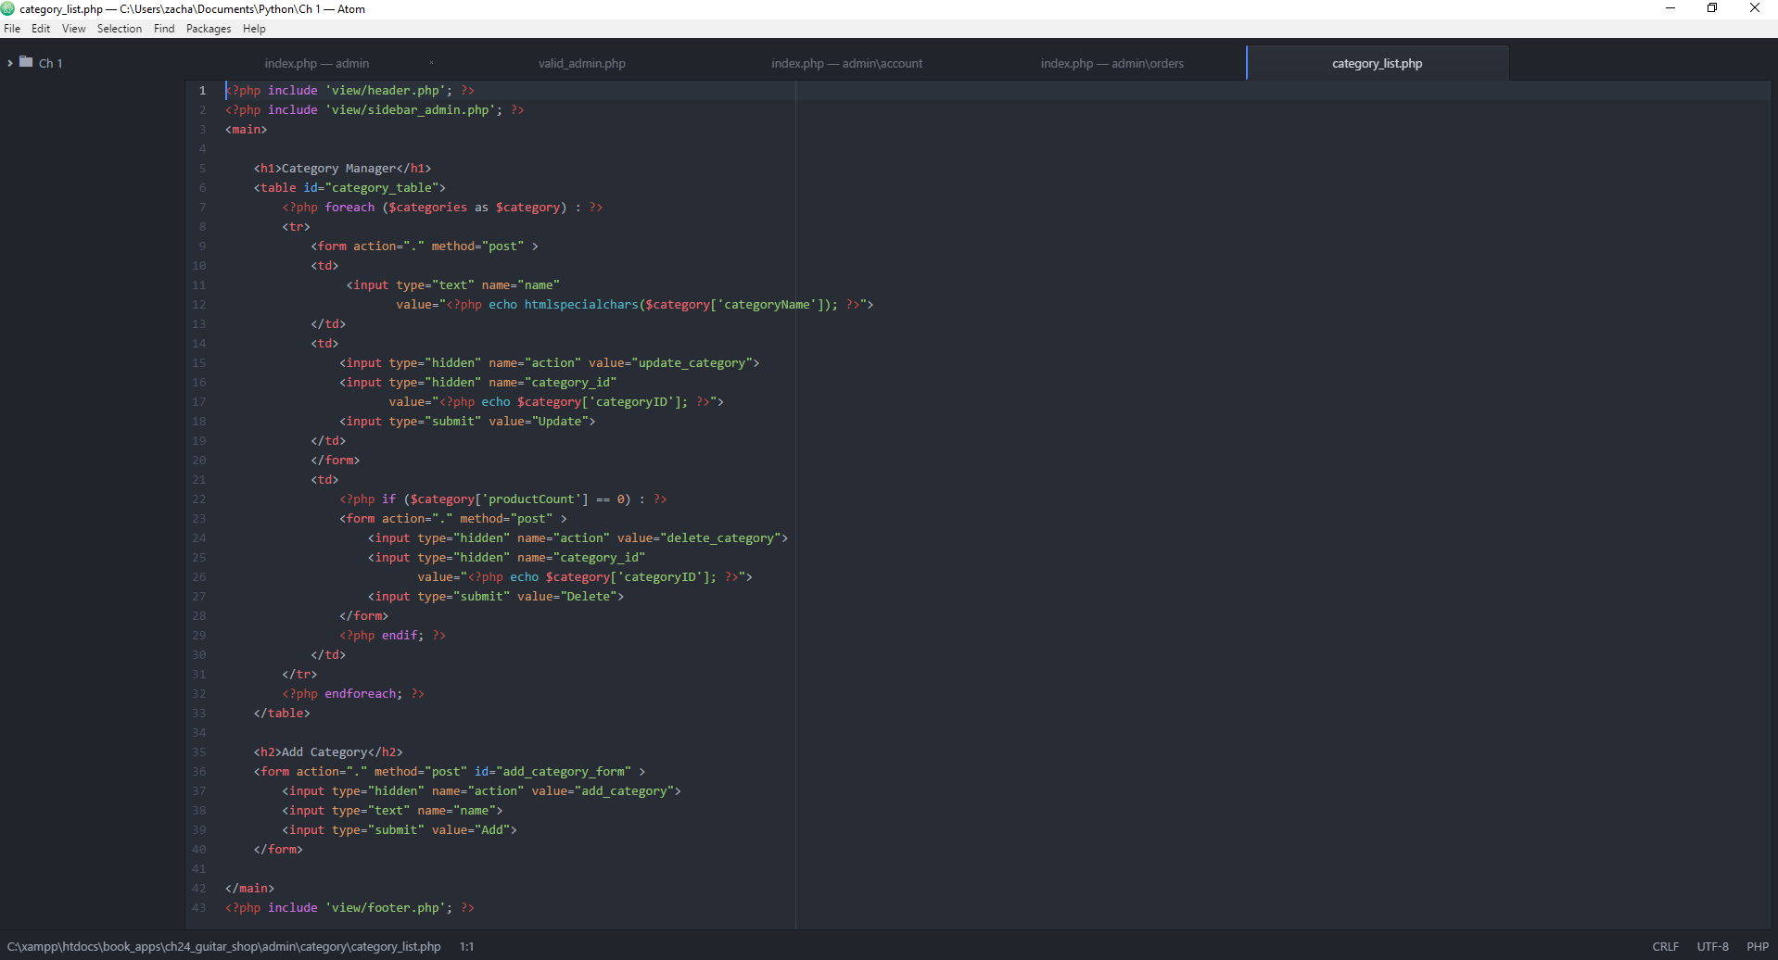

Able to review all code for the admin part.

**Ex 24-2 #1:**

One thing I would like to change is the main portion of the admin page. Instead of generically listing everything I think it would be a good idea to change it to “I want to….” This I feel is a little bit more user friendly. Not all workers for this will have strong computer skills. I think this application overall could be more user friendly when it comes to wording. Other than that, and some design aspects this is a good prototype.

**Ex 24-2 #2:**

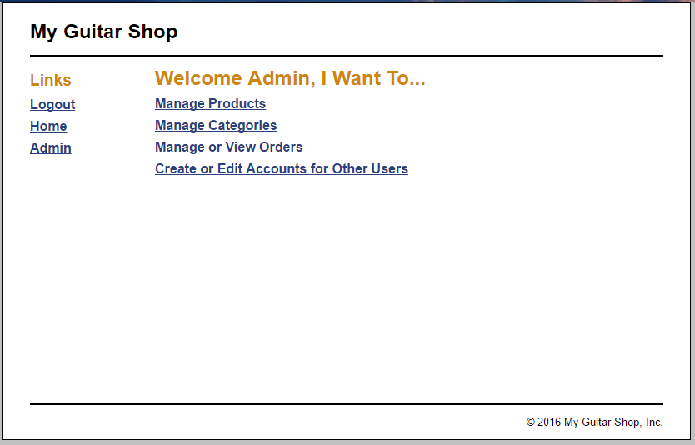

Made my suggested change.